**Fake News on Facebook – Does it influence last US Presidential Election?**

# Abstract

Hyperpartisan political Facebook pages and websites are consistently feeding their millions of followers false or misleading information, according to an analysis by BuzzFeed News. The review of more than 1,000 posts from six large hyperpartisan Facebook pages selected from the right and from the left also found that the least accurate pages generated some of the highest numbers of shares, reactions, and comments on Facebook — far more than the three large mainstream political news pages analyzed for comparison.

Buzzfeed analysis of three hyperpartisan right-wing Facebook pages found that 38% of all posts were either a mixture of true and false or mostly false, compared to 19% of posts from three hyperpartisan left-wing pages that were either a mixture of true and false or mostly false. The right-wing pages are among the forces — perhaps as potent as the cable news shows that have gotten far more attention — that helped fuel the rise of Donald Trump.

These pages, with names such as [Eagle Rising](https://www.facebook.com/theEagleisRising/) on the right and [Occupy Democrats](https://www.facebook.com/OccupyDemocrats/) on the left, represent a new and powerful force in American politics and society. Many have quickly grown to be as large as — and often much larger than — mainstream political news pages.

The rapid growth of these pages combines with BuzzFeed News’ findings to suggest a troubling conclusion: The best way to attract and grow an audience for political content on the world’s biggest social network is to eschew factual reporting and instead play to partisan biases using false or misleading information that simply tells people what they want to hear. This approach has precursors in partisan print and television media, but has gained a new scale of distribution on Facebook.

BuzzFeed News selected three large hyperpartisan Facebook pages each from the right and from the left, as well as three large mainstream political news pages. All nine pages have earned the coveted verified blue

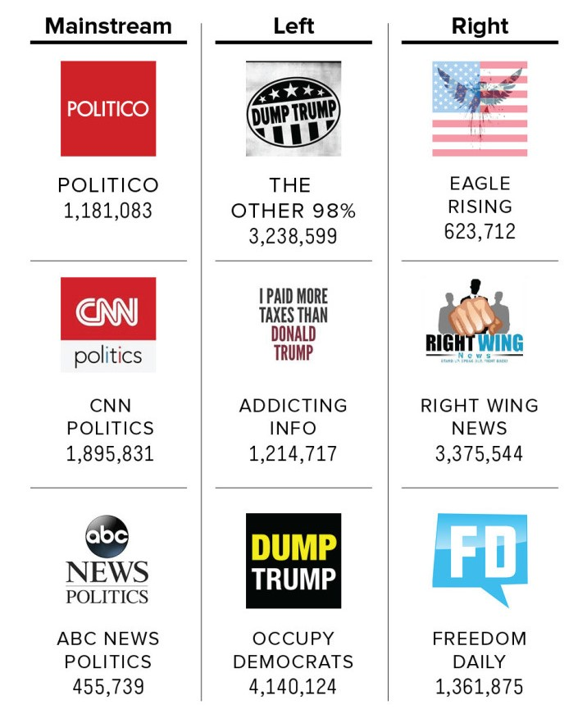

# Dataset

Posts could be rated “mostly true,” “mixture of true and false,” or “mostly false.” If a post that was satirical or opinion-driven, or that otherwise lacked a factual claim, we rated it “no factual content.”

BuzzFeed also gathered additional data: Facebook engagement numbers (shares, comments, and reactions) for each post were added from the Facebook API, and we noted whether the post was a link, photo, video, or text. Raters were asked to provide notes and sources to explain their rulings of “mixture of true and false” or “mostly false.” They could also indicate whether they were unsure of a given rating, which would trigger a second review of the same post in order to ensure consistency. Any discrepancies between the two ratings were resolved by a third person. That same person conducted a final review of all posts that were rated mostly false to ensure they warranted that rating.

In the end, Buzzfeed team rated and gathered data on 2,282 posts. There were 1,145 posts from mainstream pages, 666 from hyperpartisan right-wing pages, and 471 from hyperpartisan left-wing pages. The difference in the number of posts for each group is a result of them publishing with different frequencies.

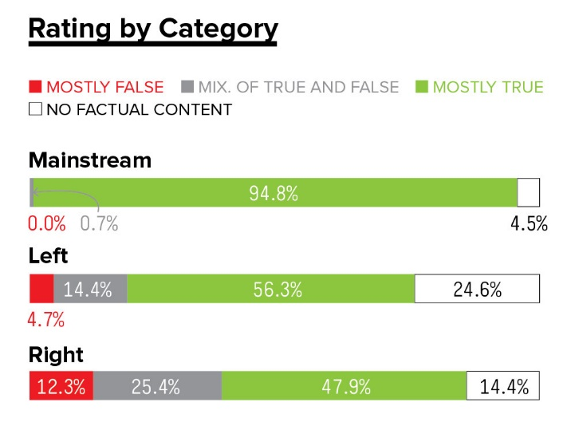

**The Dataset is available in the below URL below:**

<https://github.com/BuzzFeedNews/2016-10-facebook-fact-check/blob/master/data/facebook-fact-check.csv>

There are 9 input variables (mentioned below, except Account Identifier & Post Identifeir) which influence the ‘Rating’ (output variable) of the content.

Account Identifier

Post Identifier

Category

Page

Post URL

Date Published

Post Type

Debate

Share Count

Reaction Count

Comment Count